---------------------------------------------------------------------------
ReadMe File
---------------------------------------------------------------------------
Prioritizing cancer-related microRNAs by integrating microRNA and mRNA datasets

Daeyong Jin, Hyunju Lee
Data Mining & Computational Biology Lab
Gwangju Institute of Science & Technology
Gwangju, South Korea
http://combio.gist.ac.kr/
---------------------------------------------------------------------------
I. List of input files
* Please notice that all data in this page is simulation data. Our data just shows input format. We originally used expression data from TCGA (The Cancer Genome Atlas) and gene-miRNA prediction pairs from Pictar, targetScans and microCosm.

1. “./1_compute_feature_values /data"
2. "./2_integrate_feature_values /data"

II. List of Output files
1. “./1_compute_feature_values /result"
2. "./2_integrate_feature_values /result"

III. List of Source Codes
1. "./1_compute_feature_values /src"
2. "./2_integrate_feature_values /src"

---------------------------------------------------------------------------
Description
----------------------------------------------------------------------------------
I. Compute each feature value (F1, F2 and F3).
Source: "./1_compute_feature_values /src"
Input : “./1_compute_feature_values /data"
Output : “./1_compute_feature_values /result”

1. “Compute_F1.r”
Calculate F1, the average miRNA expressions of all tumor samples.

(input)
(1) “simulated_mirna_exp.txt”
MiRNA expression data from tumor samples (expression values > 0)

(output)
(1) “F1_ave_mirna_exp.txt”
Each row represents each F1 values for each miRNA (The average miRNA expressions of all tumor samples)

2. “Compute_F2.r”
Calculate F2, the average of absolute Pearson correlation coefficients (PCCs) between miRNA and all gene expressions.

(input)
(1) “simulated_mirna_exp.txt”
MiRNA expression data from tumor samples (expression values > 0)

(2) “simulated_gene_exp.txt”
Gene expression data from tumor samples (expression values > 0)
* used paired samples with same order

(output)
(1) “F2_ave_cor.txt”
Each row represents each F2 values for each miRNA (the average of absolute Pearson correlation coefficients (PCCs) between miRNA and all gene expressions.)

3. “Compute_F3.r”
Calculate F3, the number of the predicted targets for each miRNA. First, we extract gene-miRNA pairs from gene-miRNA prediction database such as pictar, targetScans and microCosm. Then we get the union set of gene-miRNA prediction pairs. Then we calculate the number of the predicted targets for each miRNA.

(input)
(1) “gene_list.txt”
a list of genes in gene expression data we used

(2) “mirna_list.txt”
A list of miRNAs in miRNA expression data we used

(3) “simulated_GMI.txt”
A list of predicted gene-miRNA pairs

(output)
(1) “F3_n_predicted_target.txt”
Each row represents each F3 values for each miRNA (the number of the predicted targets for each miRNA.)

II. Integrating features values based on order statistics
Source: "./2_integrate_feature_values/src"
Input : “./ 2_integrate_feature_values/data"
Output : “./ 2_integrate_feature_values/result”

1. “integration_using_order_statistics.r”
Integrate three feature values using order statistics in below figure.

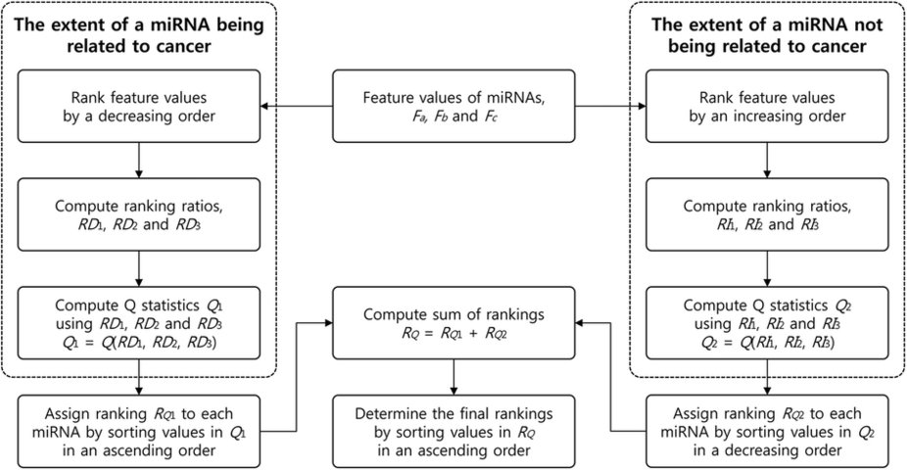

(input)
(1) “F1_ave_mirna_exp.txt”
The average miRNA expressions values of all tumor samples

(2) “F2_ave_cor.txt”
The average of absolute Pearson Correlation Coefficients (PCCs) between miRNA and all gene expressions.

(3) “F3_n_predicted_target.txt”
The number of the predicted targets for each miRNA.

(output)
(1) “integration_result.txt”
Integration result of three features. Final ranking, miRNA, Q1, RQ1, Q2, RQ2 and RQ are outputted.

